NYSA HOTSTOVE SOFTBALL LEAGUE RULES

(amended 4/10/2024)

ALL MANAGERS MUST ENTER SCORES ON THE WEBSITE AFTER THE END OF THE GAME.

1. Grievous individual misconduct on the part of coaches, parents, or players, on or off of the field, will not be tolerated. Please respect the parks and the park employees.
2. Anyone ejected from a game, or the field, will be suspended for the next two (2) games following the ejection. Gross Misconduct could result in ejection from the entire league. If a parent is ejected his child also is ejected from that game.
3. No protests allowed! Umpires will handle all disputes and their decisions are final. Please respect the umpires!
4. Coin flip for home team called by the team that traveled the furthest.
5. Game time is the forfeit time. Teams must have 8 players to start the game. Forfeit game is 7-0. Coaches are responsible for reporting the scores. Make sure we have all of your scores after each game and before you leave for the day. Winning team should enter scores on their dashboard.
6. All batters and runners will wear helmets. If chinstraps are attached, they must be affixed in the proper method.
7. For 10U/12u Rec only, 5 run maximum per inning until the last inning. There is no run limit per inning for 10U travel. 10U rec divisions Federated and Union division. 10U travel division is the

National division. 12U rec divisions federated and union division. 12U travel division is the National division.

1. 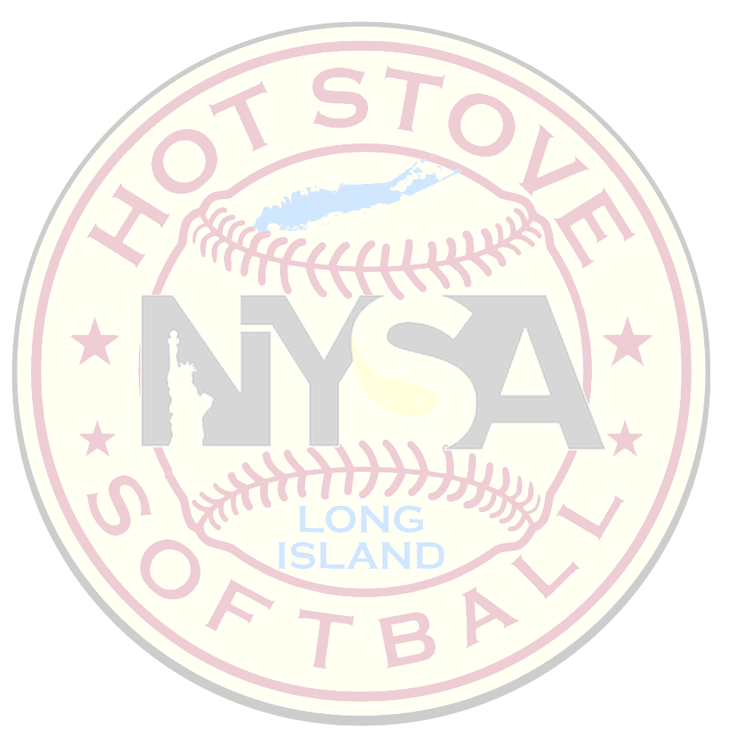Mercy Rule: 12 runs after 3 innings, 10 runs after 4 innings, 8 runs after 5 innings. For the first 5 innings it is equal at bats. After inning 5 the away team can walk off if they go up by 8 runs in the top of the 6th or in the top of the 7th.
2. Speed Up Rules
   * 1. After the first inning the pitcher may throw no more than 3 warm-up pitches between innings.
     2. No infield or outfield warm-up after the 1st inning. Please exit the benches quickly, keep them clean, and keep the games moving.
     3. Courtesy runner for the pitcher and catcher allowed anytime. The courtesy runner must be the last batted out. If the last batted out is the pitcher or catcher, then the previously batted out can serve as the courtesy runner.
3. In 10u rec and travel runner may leave after the pitch crosses the plate.10U rec league there will be no stealing of home. For 10U travel leagues if both teams agree before the game to play steal on release that is fine. If 1 team says no then we will use league rules which states stealing when ball crosses the plate.

. 12u/14u/18u travel and rec runner may leave after pitcher’s release.

Stealing of Home- In the 10U Union and Federated division there is NO stealing home. If both coaches agree, you may play stealing home. If one doesn’t, then league rules apply. Home must be earned.

1. Universal batting order may be used for all divisions. 10u and 12U Rec can use 4 outfielders and must be LF, LC, RC, and RF. No “short-centerfielder” is allowed. 10U - The outfielders must be at least 30 feet past the baselines.
2. 14U/16U/18U - Pitching distance will be 43’ and a 12” softball will be utilized.

12u Pitching distance is 40” and use 12” softball.

10U - Pitching distance will be 35’ and 11” softball will be used.

1. There will be 1 ASA umpire for all divisions. 2 Umpires for Championship games
2. 10U Rec Division and 10U travel division only- No dropped third strike. No continuation No infield Fly

10U all divisions you are permitted to pay with 4 outfielders

1. 12U Rec and 12U travel dropped third strike and infield fly are in play. In 12U rec if both coaches agree to no dropped third or infield fly that is fine if 1 coach says no then both infield fly and dropped third are in play.

14U 16/18U Travel will both have dropped third strike and Infield Fly Rule

1. Game times – 1 hour 40 minutes FINISH the inning! 3 innings is considered a full game

If a game gets called for darkness or weather and a full inning isn’t completed game reverts back to last full inning completed.

GAME LENGTH: 10u – 6 Innings, 12u,14U, 16/18U – 7 innings - All games are 1 hour 40 min – finish the inning,– International Tiebreakers shall be used for PLAYOFFS at expiration of play time. Umpire will document official start time.

1. LINEUP Option’s- Universal Batting Order (Bat all girls)

DP/Flex Option

Extra Hitters – 2 Max.

If using DP/Flex option only 1 EH.

1. Metal cleats are only permitted on dirt fields at the 14U 16U/18U divisions. NO metal cleats permitted on turf fields or in the younger divisions
2. No Guest players are permitted for the playoffs. Guest players can be used for regular season games Rosters must be submitted and must include First and Last name, Date of birth and Jersey number
3. 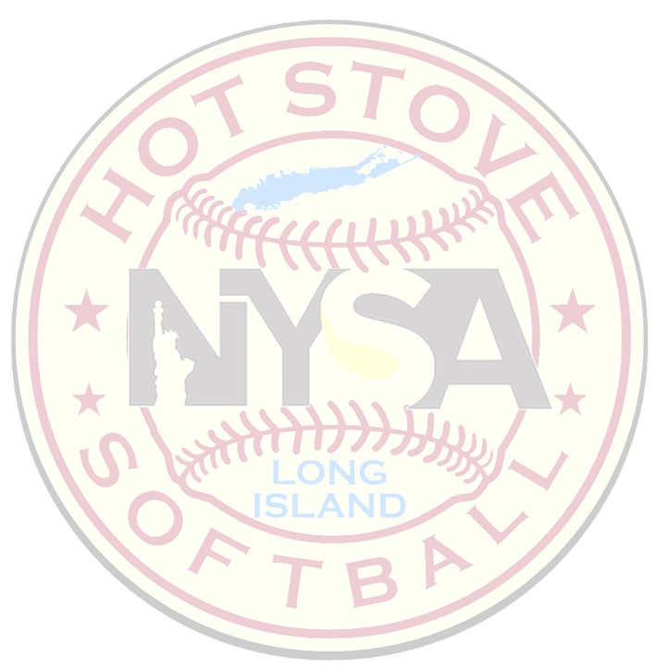Injuries- If a player is hurt and has to come out of the game a sub may be entered in for that player. If a team has no subs and the player can’t continue, she will be removed from the lineup with no penalty. This is only for pool play or regular season games. That player if removed may NOT return to the game. If it’s a playoff game and the player must be removed, and the team has no subs then every time that players spot comes up in the lineup it will be a automatic OUT.
4. Umpire fees are 35 dollars per tam per game ( Single umpire). Paid cash before the 1st pitch
5. Standings tie breakers
   * Head to head if more then 2 teams tied then head to head goes out the window
   * Runs allowed
   * Runs scored
   * Coin flip

10U rec divisions- Federated & Union

10U Travel division- National

12U Rec division- Federated & Union

12U Travel Division- National